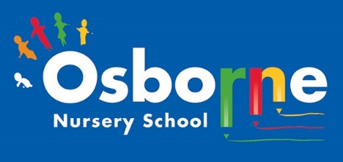
Osborne News
October 2026
www. osbornenurseryschool.co.uk 0121 675 1123

Nursery News:
What a busy month! Well done to all our children for settling back into nursery and well done to those that have joined us.
The children have been busy getting to know our nursery – they have enjoyed learning inside and outside!

The children have been learning our routines and making new friends.
We have events coming up this month so please keep an eye on Tapestry so you can book in and attend workshops and parent/ carer meetings.
Communication with nursery:
Remember to telephone us on 0121 675 1123 if your child is too ill to be at nursery.

Dates for your diary:
In October – Playdough workshops, Road safety walks and parent/ carer child progress meetings. Details to follow.
Wednesday 30th September – The Animal man will visit nursery!
WC: 5th October 2026 – Playdough workshops for our Little Learners
Wednesday 7th October – NURSERY CLOSED – Staff training.
WC: 19th October – Parent/ carer meetings
Monday 26th – 30th October – HALF TERM – nursery closed.
WC: 2nd November – Diwali and firework safety
Wednesday 2nd December – NURSERY CLOSED staff training.
Friday 18th December 2026 – Last day of the Autumn term


Startwell:
We will be teaching the children all about Startwell and the characters. This is Active Asra:



Active Azra is all about moving more and sitting less; children should move as much as possible. We describe this as the belly button being on the move!
We encourage the children to move at nursery – when they are playing inside or outside.
How much do you move at home?


Cool Kittens at Osborne Nursery. Attendance is very important at Nursery. We like to see you for all of your sessions each week. We like families to aim for attendance to be between 95 and 100%.
The groups with the best attendance in September is Acorns morning group 95% and Squares morning group – 94%. FANTASTIC!! Keep it up everyone.

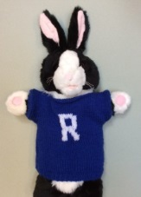
We are a Silver Award Rights Respecting School. Look out for Tapestry posts about different activities the children have been part of and the rights that we are sharing with the children.
Ronnie Rabbit will soon make an appearance and help the children to learn about their rights.

Rights Respecting Schools Award (RRSA)
All children have rights, no matter who they are, where they live, what language they speak, what their religion is, what they think, what they look like, if they are a boy or girl, if they have a disability, if they are rich or poor, and no matter who their parents or families are or what their parents or families believe or do. No child should be treated unfairly for any reason.



Internet Safety:
Each month we will be looking at using electronic devises safely at home and sharing helpful tips. We need to keep our children safe and help them to understand how to play games, use the internet and different devises safely.
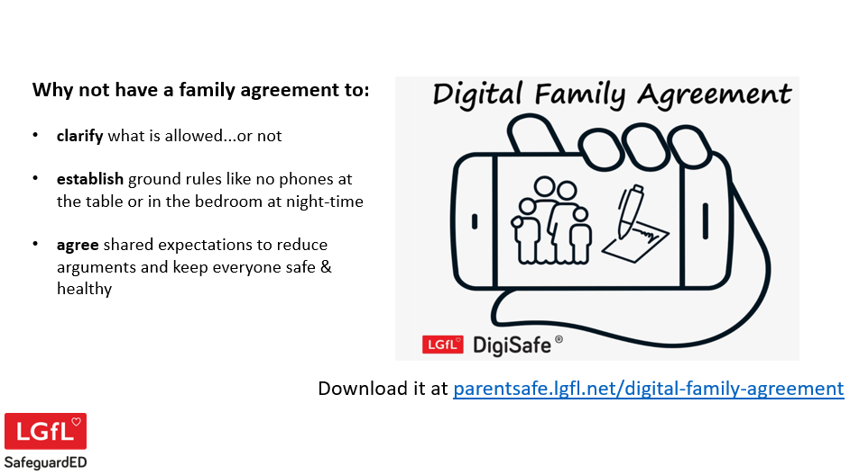

Do you have rules for using phones and screens at home? It’s a good idea to set rules and boundaries.
When can they play?
How long are they allowed to spend on a device?
Where will they use the devise?

This would be useful discussion to have with your family so that the rules and boundaries are in place for safe use of technology in the home.

Explorers will be reading this lovely story book about families by Tod Parr – we are all lucky that we live with people that care for us.
We will share this book on Tapestry with you!
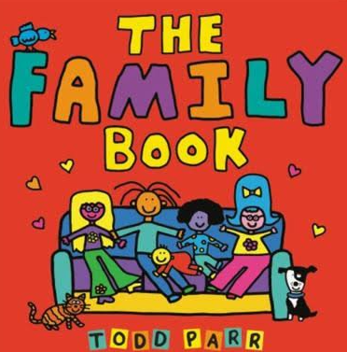

Recommended reading this month:
Our Little Learners have been reading
Dear Zoo by Rod Campbell

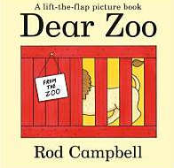
The children love discovering the animals the zoo has sent – a monkey, a lion and even an elephant! But will they ever manage to send the perfect pet?


If your child is due to start Reception in September 2027 you can apply for a Birmingham reception (primary school) place through the Birmingham City Council online admissions portal, which opens on 1 October 2026 and closes on 15 January 2027.

